MAAA Inc. 68th National Aircraft Championships
Southeast Queensland – Brisbane
April 9th -19th 2015
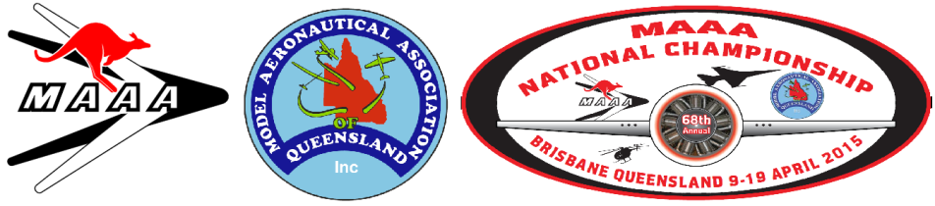
68th Nationals Pilot/Team Entry Form

Surname |  | First Name | FAI No.
Address |  | Town/City | P/Code
Phone H: |  | Mobile: | Email Address:
Team Member
Event |  | Team Members Name | FAI No.
Email Address:
Fees must be paid to the “MAAQ 2015”:
Payment Method.  Electronic Funds Transfer  Cheque. | Electronic Funds Transfer:  Post a copy of the EFT transaction with your completed Application Form as proof of payment.  MAAQ 2015 Account: BSB: 034-127 Acct#: 313261  Please include your MAAA AUS number and first three letters of your Surname in the EFT transaction text (e.g. 41557DOD).
 | Please Indicated with an "x"
 | RADIO CONTROL |  |  |  |  | CONTROL LINE |  |  |  |  | FREE FLIGHT
 | Standard Duration |  |  |  |  | F2A Speed |  |  |  |  | F1A Glider
 | Old Timer Texaco |  |  |  |  | Combined SPEED & JET |  |  |  |  | F1B Wakefield
 | Old Timer 1/2A Texaco |  |  |  |  | F2B Aerobatics Exp. |  |  |  |  | F1C Power
 | Nostalgia |  |  |  |  | F2B Aerobatics Adv. |  |  |  |  | F1G Coupe D’Hiver
 | '38 Antique |  |  |  |  | F2D Combat |  |  |  |  | F1H Glider
 | Gordon Burford |  |  |  |  | OPEN Combat |  |  |  |  | F1J 1/2A Power
 | Old Timer 2cc |  |  |  |  | VINTAGE Combat |  |  |  |  | Open Power
 | Electric 1/2A Texaco |  |  |  |  | JNR. 2.5cc Combat |  |  |  |  | Open Rubber
 | Electric Texaco |  |  |  |  | ½ A Combat |  |  |  |  | Outdoor H.L.G.  Postal Address:  The Registrar,  16 Illidge Road  Victoria Point Qld 4165  (Please do not post cash)
 | Electric Duration |  |  |  |  | F4B Scale |  |  |  |  | Day Scramble
 | F3C Helicopter |  |  |  |  | F2C Team Race T |  |  |  |  | Night Scramble
 | Helicopter Advanced |  |  |  |  | Goodyear T |  |  |  |  | Catapult Glider
 | Helicopter Novice |  |  |  |  | Mini Goodyear T |  |  |  |  | P 30 Rubber
 | Aerobatics F3A |  |  |  |  | Open Rat Race T |  |  |  |  | Vintage Rubber
 | Aerobatics Expert |  |  |  |  | 2.5cc Rat Race T |  |  |  |  | Vintage Power
 | Aerobatics Advanced |  |  |  |  | Class 2 Team Race T |  |  |  |  | Vintage Glider  68th Nationals get together night/dinner:  1. Wednesday Night 15th. Buffet style dinner, with get together  Notes: Social events  To help organiser these events, please Tick if attending:-  1/ RC Indoor will be provided as a social event free for all MAAA members only.  2/ Night Flying social event at SAAMBR Sat 18th  3/ Fun Fighter social event at SAAMBR Sun 19th
 | Aerobatics Sportsman |  |  |  |  | Vintage A Team Race T |  |  |  |  | OZ Diesel
 | FA1 Pylon T |  |  |  |  | Classic B Team Race T |  |  |  |  | FF INDOOR
 | Pylon Quickie 500 |  |  |  |  | Bendix T |  |  |  |  | F. F. Scale
 | Pylon Formula 400  F5D Electric pylon |  |  |  |  | JNR. 2.5cc Rat Race T |  |  |  |  | Indoor H.L.G.  F1L
 | F5J Electric Glider |  |  |  |  | Classic FAI T/R T |  |  |  |  | FID Microfilm
 | LEG Electric |  |  |  |  | Classic Stunt |  |  |  |  | Indoor Catapult
 | F5B Electric Glider |  |  |  |  | Vintage Stunt |  |  |  |  | Hangar Rat & Scramble
 | Open Thermal |  |  |  |  | Indoor |  |  |  |  | Peanut Scale
 | F3K H.L.G. |  |  |  |  | Z Class
 | F3B Glider |  |  |  |  |  | Administration Fee ($50) (Maximum Admin + Event Fee = $100.00) (late Administration Entry Fee = $100 received after 27th March 2015) $50.00  Event Fees Administration Fee $50.00  Event Fees $15.00 per Senior $2.00 per Junior  Number of Events Senior x Event Fee $15 =  Number of Events Junior x Event Fee $2 =  Helper fee for team events-No of Events x Event Fee $5 =  Extras Over and Above Goodies Bag  Metal Badges x $5.00  Decals X $3.00  Cap with Logo x $20.00  Brimmed Hat with Logo x $25.00  Polo Shirt with Embroidered Logo Qty = Size = x $40.00  Total =
 | F4C SCALE
 | Large Scale Flying Only
Sport Scale Flying Only
Large Scale Aero Basic
Large scale Aero Sportsman
Large Scale Aero Inter
Large Scale Aero Adv
Large Scale Aero Unlimited
Large Scale Aero Free Style

Note:
1. Entrants Bag will include a Nat’s Metal Badge & Decal. Caps Brimmed hat and Nationals Polo Shirt are NOT INCLUDED, but may be purchased by forward ordering on this Entry Form.

2. Team members need to pay Admin + Event fee of $5.

3. CLOSING DATE FOR ENTRIES – 27th March 2015

Social Events so far confirmed:
- Indoor Stadium open flying
- Swap Meet
- Night Scramble
- Open Night-flying - TMAC

STATEMENT OF AGREEMENT:- I agree to abide by all rules laid down by the Association.
I agree to compete in a Sportsman like manner & will also make myself available to assist with the running of the 68th Nationals if I am asked to help.

Signed: …………………………………………………………………….

